SOA Project
  - Fintina Vlad
  - Group 258-1
Application Overview
This application is an online ticketing platform designed for selling tickets to football matches and providing detailed information about upcoming games. It is intended for users who want to purchase match tickets or simply browse match details online.
The platform allows users to view a list of available football matches and access detailed information about each one. While browsing matches does not require authentication, users must be logged in to purchase tickets. After a ticket is purchased, the system simulates sending an invoice to the user via email. Currently, this email functionality is implemented as a console output containing the invoice details.
In summary, a user can:
- Log in to the application
- View a list of football matches
- View detailed information about a specific match
- Purchase a ticket for a selected match
- Receive a simulated invoice via email after purchase
Backend Architecture
The backend is built using a microservices architecture consisting of six services, each with a distinct responsibility:
- Authentication Service (authservice) – Handles user authentication and login functionality.
- Matches Service (matches-service) – Provides information about available football matches.
- Tickets Service (tickets-service) – Manages ticket purchasing and ticket generation.
- Invoices Service (invoices-service) – Generates invoices for purchased tickets.
- Email Service (email-service) – Simulates sending invoice emails to users.
- Load Balancer (Nginx) – Acts as an entry point to the system and distributes incoming requests among selected backend services.
The load balancer routes client requests to the authservice, matches-service, and tickets-service.
Inter-service communication is handled asynchronously using message queues:
- The tickets-service communicates with the invoices-service through a Kafka queue to trigger invoice generation after a ticket purchase.
- The invoices-service then communicates with the email-service via a RabbitMQ queue to simulate sending the invoice email.
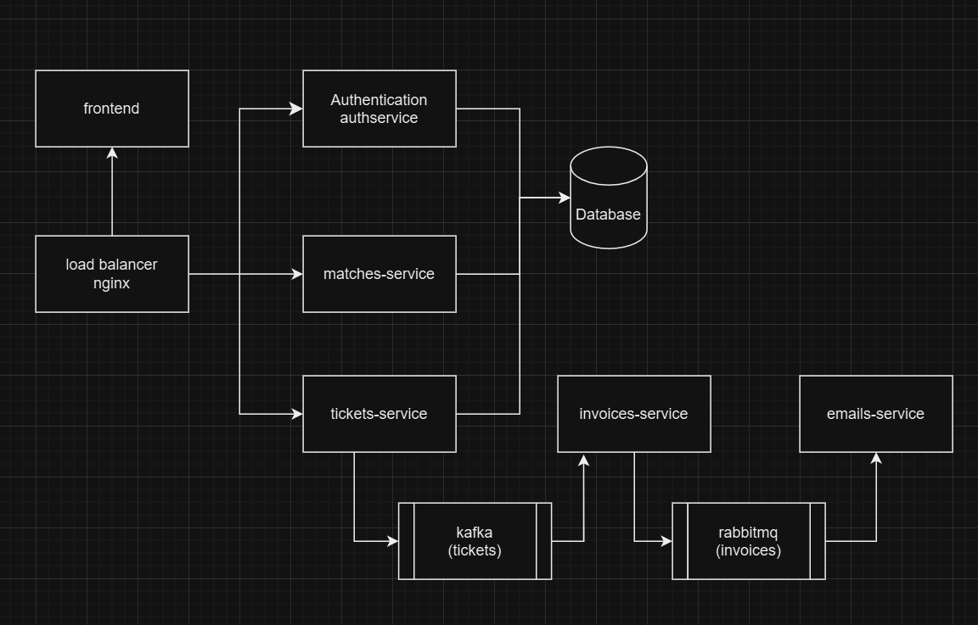
Frontend Overview
The frontend is implemented as a separate microservice responsible for the user interface. It provides the following functionality:
- Login Page – Allows users to authenticate before purchasing tickets.
- Matches List – Displays all available football matches.
- Match Details – Shows detailed information about a selected match.
- Ticket Purchase – Enables authenticated users to buy tickets for a match.
The entire application, including both frontend and backend services, is containerized using Docker. Docker is used to build images and deploy containers, ensuring a consistent and portable environment across development, testing, and production. This approach allows all services—frontend, backend, and supporting components like RabbitMQ and Kafka—to be managed and run seamlessly together.

UML Diagram Frontend Package
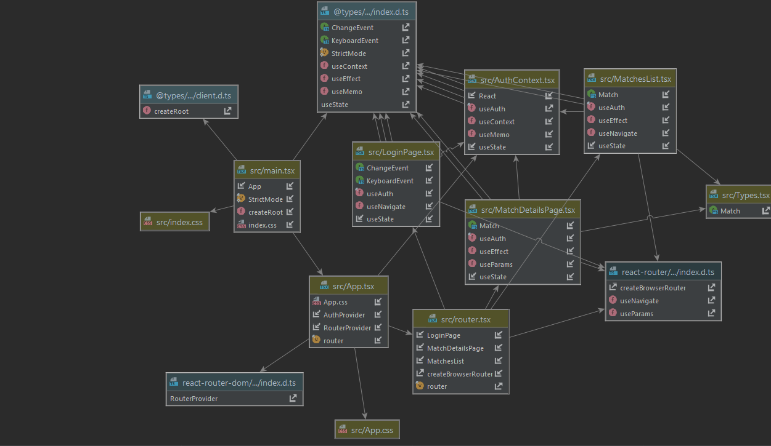

C4 Context Diagram:
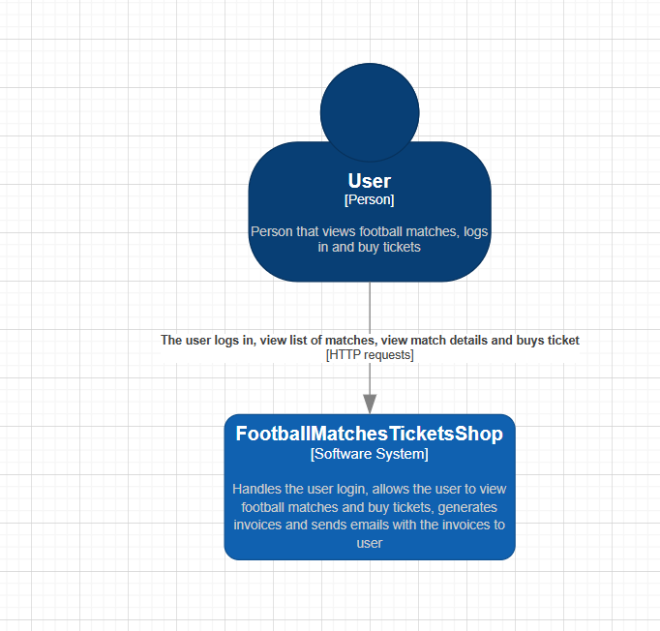

C4 Container Diagram:
